**AMERICAN INTERNATIONAL UNIVERSITY BANGLADESH**

**Faculty of Engineering**

**Laboratory Report Cover Sheet**

***Students must complete all details except the faculty use part.***

Please submit all reports to your subject supervisor or the office of the concerned faculty.

**Lab Title: Study of Digital to Digital Conversion (Line Coding) using MATLAB**

Experiment Number: **04** Due Date: **19 /03/2024**  Semester: **Spring 2023-2024**

Subject Code: **COE3103** Subject Name: **DATA COMMUNICATION** Section: **_E_**

Course Instructor: **NOWSHIN ALAM**  Degree Program: **B.Sc. CSE**

**Declaration and Statement of Authorship:**

1. I/we hold a copy of this report, which can be produced if the original is lost/ damaged.
2. This report is my/our original work and no part of it has been copied from any other student’s work or from any other source except where due acknowledgement is made.
3. No part of this report has been written for me/us by any other person except where such collaboration has been authorized by the lecturer/teacher concerned and is clearly acknowledged in the report.
4. I/we have not previously submitted or currently submitting this work for any other course/unit.
5. This work may be reproduced, communicated, compared and archived for the purpose of detecting plagiarism.
6. I/we give permission for a copy of my/our marked work to be retained by the school for review and comparison, including review by external examiners.

**I/we understand that**

1. Plagiarism is the presentation of the work, idea or creation of another person as though it is your own. It is a form of cheating and is a very serious academic offence that may lead to expulsion from the University. Plagiarized material can be drawn from, and presented in, written, graphic and visual form, including electronic data, and oral presentations. Plagiarism occurs when the origin of the material used is not appropriately cited.
2. Enabling plagiarism is the act of assisting or allowing another person to plagiarize or to copy your work.

|  |  |  |  |  |  |  |  |  |  |  |
| --- | --- | --- | --- | --- | --- | --- | --- | --- | --- | --- |
|  | Group Number (if applicable): 08 | | | Individual Submission | | | Group Submission | |  |  |
|  |  |  |  |  |  |  |  |  |  |  |
|  |  |  |  |  |  |  |  |  |  |  |
|  | **No.** |  | **Student Name** |  |  | **Student Number** | **Student Signature** | **Date** |  |  |
|  | **Submitted by:** | |  |  |  |  |  |  |  |  |
|  |  |  | **A. F. M. RAFIUL HASSAN** |  |  |  |  |  |  |  |
| **1** | |  |  |  |  | **22-47048-1** |  |  |  |  |
|  |  |  |  |  |  |  |  |  |  |  |
|  | **Group Members:** | |  |  |  |  |  |  |  |  |
|  |  |  |  |  |  |  |  |  |  |  |
| **2** | | **MD. SHOHANUR RAHMAN SHOHAN** |  |  |  | **22-46013-1** |  |  |  |  |
|  |  | **MD. TAHSIN HASIB** |  |  |  |  |  |  |  |  |
| **3** | |  |  |  |  | **22-46026-1** |  |  |  |  |
|  |  | **KHUSHBU ALAM RAHI** |  |  |  |  |  |  |  |  |
| **4** | |  |  |  |  | **22-46947-1** |  |  |  |  |
|  |  | **MD. ASHIKUZZAMAN ABIR** |  |  |  |  |  |  |  |  |
| **5** | |  |  |  |  | **22-47006-1** |  |  |  |  |
|  |  |  |  |  |  |  |  |  |  |  |
|  |  | |  |  |  |  |  |  |  |  |
|  | ***For faculty use only:*** | |  |  |  | **Total Marks: _______ Marks Obtained: _______** | | |  |  |
|  |  |  |  |  |  |  |  |
|  |  |  |  |  |  |  |  |  |  |  |

**Faculty comments**___________________________________________________________________________

___________________________________________________________________________________________

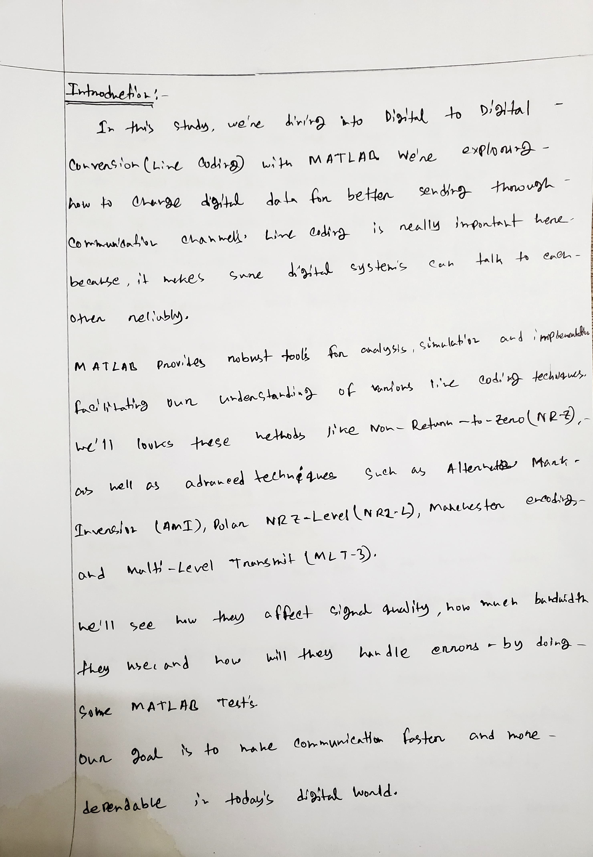

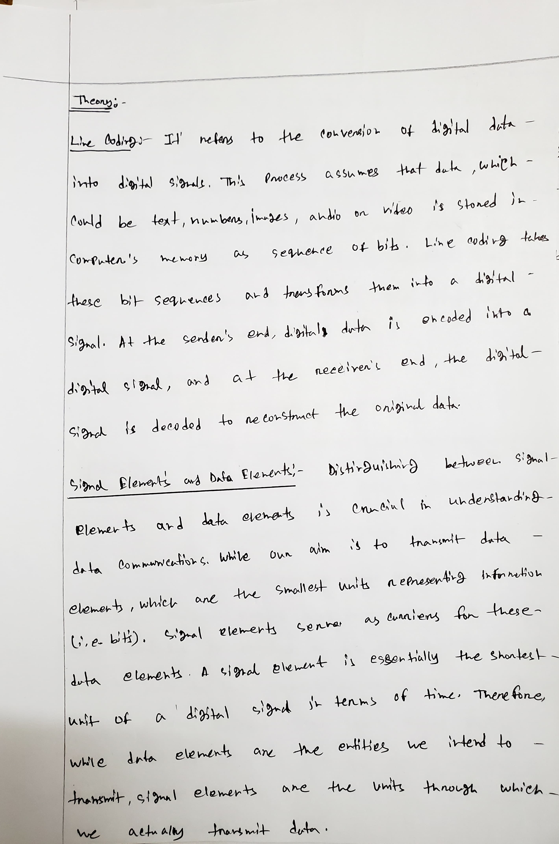

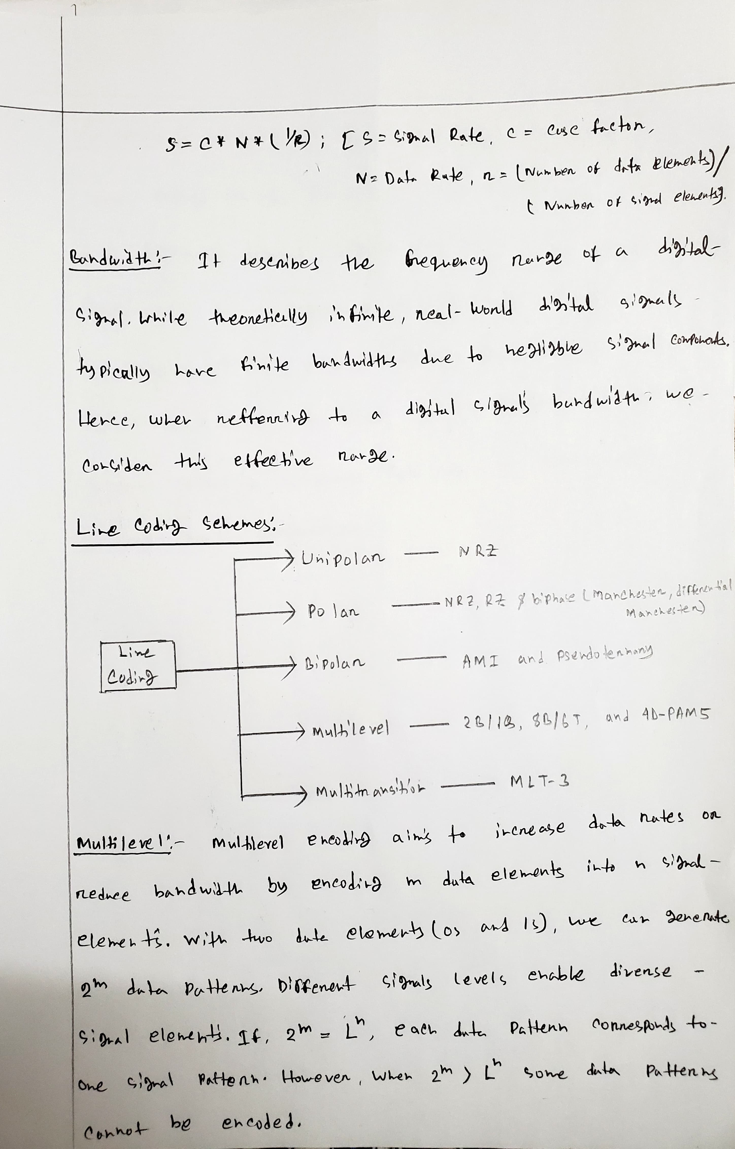

**1**

Polar NRZ-L assuming bit rate is 4 kbps.

**Code and Simulations:**

% polar NRZ-L

% 22-47048-1

% AB-CDEFG-H

clc

clear all

close all

bit_stream = [0 0 0 0 0 1 0 0 1 0 0 0];

no_bits = length(bit_stream);

bit_rate = 4000; % 1 kbps

pulse_per_bit = 1; % for unipolar nrz

pulse_duration = 1/((pulse_per_bit)*(bit_rate));

no_pulses = no_bits*pulse_per_bit;

samples_per_pulse = 500;

fs = (samples_per_pulse)/(pulse_duration); %sampling frequency

% including pulse duration in sampling frequency

% ensures having enough samples in each pulse

t = 0:1/fs:(no_pulses)*(pulse_duration); % sampling interval

% total duration = (no_pulse)*(pulse_duration)

no_samples = length(t); % total number of samples

dig_sig = zeros(1,no_samples);

max_voltage = 5;

min_voltage = -5;

for i = 1:no_bits

if bit_stream(i) == 0

dig_sig(((i-1)*(samples_per_pulse)+1):i*(samples_per_pulse)) = max_voltage*ones(1,samples_per_pulse);

else

dig_sig(((i-1)*(samples_per_pulse)+1):i*(samples_per_pulse)) = min_voltage*ones(1,samples_per_pulse);

end

end

plot(t,dig_sig,'linewidth',1.5)

grid on

xlabel('time in seconds')

ylabel('Voltage')

ylim([(min_voltage - (max_voltage)*0.2)

(max_voltage+max_voltage*0.2)])

title(['NRZ - L for ',num2str(bit_stream),''])

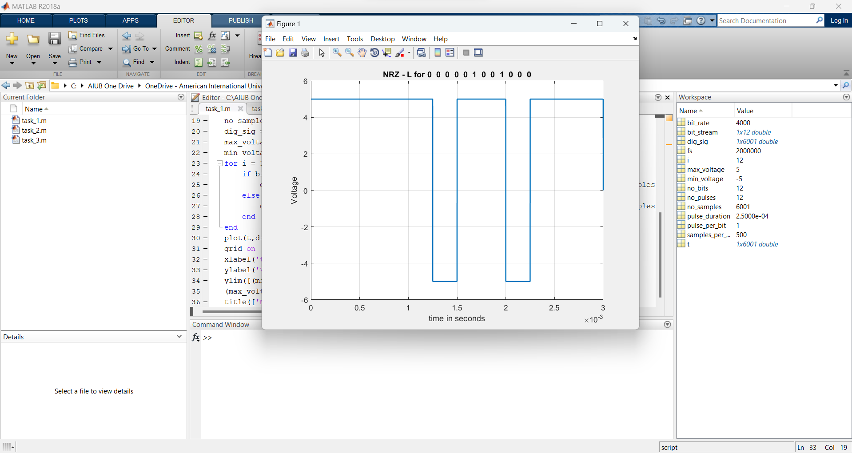

**2**

Manchester assuming bit rate is 2 kbps.

**Code and Simulations:**

% Manchester

% 22-47048-1

% AB-CDEFG-H

clc

clear all

close all

bit_stream = [0 0 0 0 0 1 0 0 1 0 0 0];

no_bits = length(bit_stream);

bit_rate = 2000; % 1 kbps

pulse_per_bit = 2; % for unipolar rz

pulse_duration = 1/((pulse_per_bit)*(bit_rate));

no_pulses = no_bits*pulse_per_bit;

samples_per_pulse = 500;

fs = (samples_per_pulse)/(pulse_duration); %sampling frequency

% including pulse duration in sampling frequency

% ensures having enough samples in each pulse

t = 0:1/fs:(no_pulses)*(pulse_duration); % sampling interval

% total duration = (no_pulse)*(pulse_duration)

no_samples = length(t); % total number of samples

dig_sig = zeros(1,no_samples);

max_voltage = 5;

min_voltage = -5;

for i = 1:no_bits

j = (i-1)*2;

if bit_stream(i) == 1

dig_sig((j*(samples_per_pulse)+1):(j+1)*(samples_per_pulse)) = min_voltage*ones(1,samples_per_pulse);

dig_sig(((j+1)*(samples_per_pulse)+1):(j+2)*(samples_per_pulse)) = max_voltage*ones(1,samples_per_pulse);

else

dig_sig((j*(samples_per_pulse)+1):(j+1)*(samples_per_pulse)) = max_voltage*ones(1,samples_per_pulse);

dig_sig(((j+1)*(samples_per_pulse)+1):(j+2)*(samples_per_pulse)) = min_voltage*ones(1,samples_per_pulse);

end

end

plot(t,dig_sig,'linewidth',1.5)

grid on

xlabel('time in seconds')

ylabel('Voltage')

ylim([(min_voltage - (max_voltage)*0.2)

(max_voltage+max_voltage*0.2)])

title(['Manchester for ',num2str(bit_stream),''])

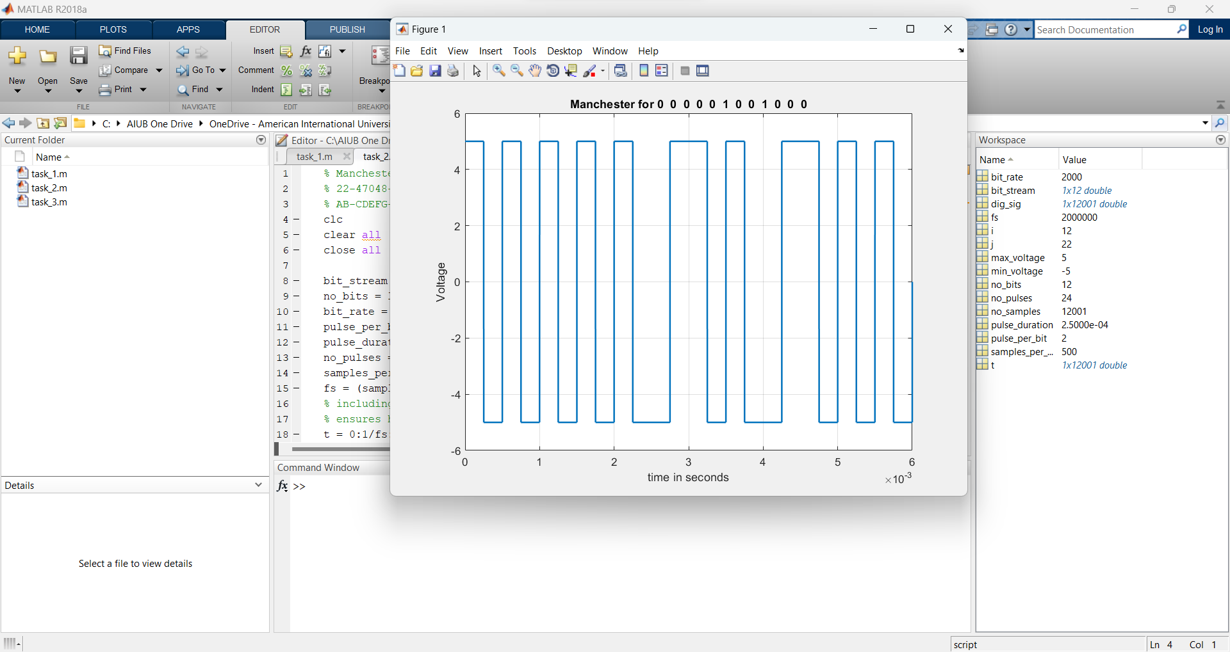

**3**

AMI assuming bit rate is 5 kbps.

**Code and Simulations:**

% AMI

% 22-47048-1

% AB-CDEFG-H

clc

clear all

close all

bit_stream = [0 0 0 0 0 1 0 0 1 0 0 0];

no_bits = length(bit_stream);

bit_rate = 5000; % 1 kbps

pulse_per_bit = 1; % for unipolar nrz

pulse_duration = 1/((pulse_per_bit)*(bit_rate));

no_pulses = no_bits*pulse_per_bit;

samples_per_pulse = 500;

fs = (samples_per_pulse)/(pulse_duration); %sampling frequency

% including pulse duration in sampling frequency

% ensures having enough samples in each pulse

t = 0:1/fs:(no_pulses)*(pulse_duration); % sampling interval

% total duration = (no_pulse)*(pulse_duration)

no_samples = length(t); % total number of samples

dig_sig = zeros(1,no_samples);

max_voltage = 5;

min_voltage = 0;

sign = 1;

for i = 1:no_bits

if bit_stream(i) == 1

dig_sig(((i-1)*(samples_per_pulse)+1):i*(samples_per_pulse)) = sign*max_voltage*ones(1,samples_per_pulse);

sign = (-1)*sign;

else

dig_sig(((i-1)*(samples_per_pulse)+1):i*(samples_per_pulse)) = min_voltage*ones(1,samples_per_pulse);

end

end

plot(t,dig_sig,'linewidth',1.5)

grid on

xlabel('time in seconds')

ylabel('Voltage')

% ylim([(min_voltage - (max_voltage)*0.2)

% (max_voltage+max_voltage*0.2)])

title(['AMI for ',num2str(bit_stream),''])

